The Ultimate Boundary Umpiring Guide
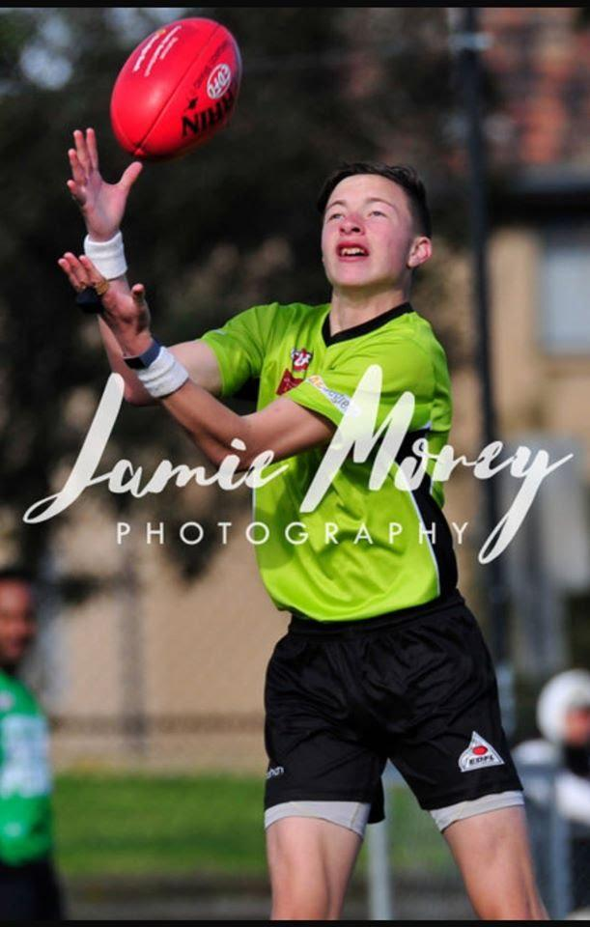

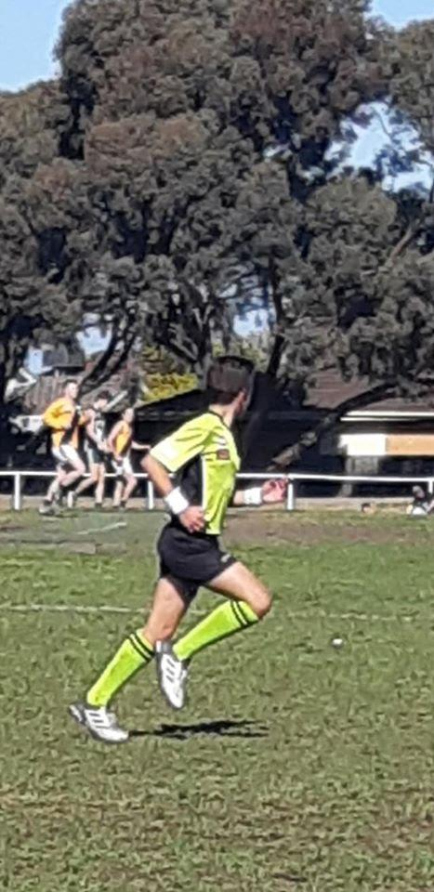

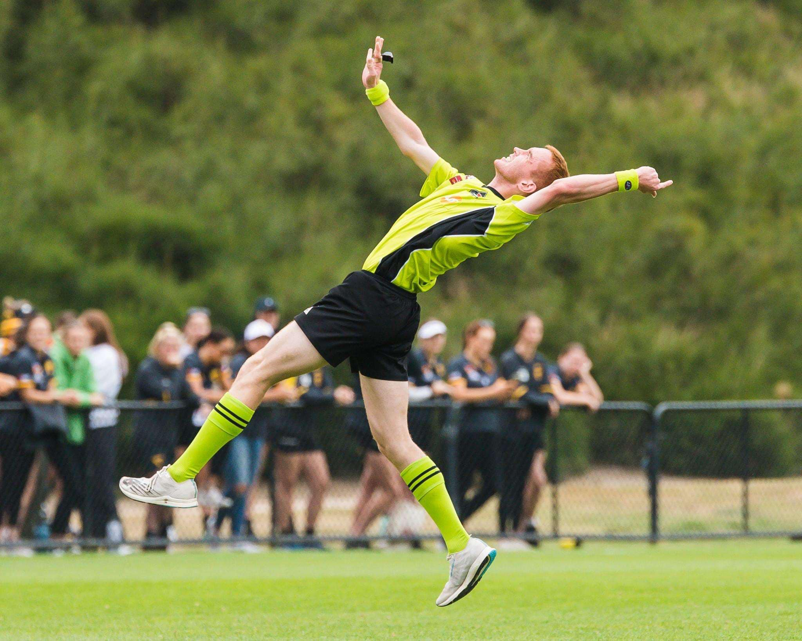

BOUNDARY UMPIRING
Boundary umpiring is a common way many people start their involvement in umpiring. It provides an opportunity to have a support role, while allowing you to experience what an umpiring career can offer. It is also a common entry level for those aspiring to become field umpires. As a boundary umpire, you can increase your awareness of aspects of the game and develop a greater match feel without some of the pressures that are often associated with field umpiring.
THE BOUNDARY UMPIRE’S ROLE AND MAIN DUTIES
It is the boundary umpire’s responsibility to:
• Be the sole judge of when the ball is out of bounds. • Apply the laws relating to boundary umpiring in accordance with the spirit of the laws. • Adjudicate when the ball has fully crossed the boundary line: – Out of bounds. – On the full. • Throw the ball back into play when out of bounds. • • Return the ball to the field umpire after a goal is scored. • Monitor the centre square for players entering or leaving during a centre ball-up. • Monitor the 6-6-6 before a centre ball-up, no more than 6 allowed in each position.

A BOUNDARY UMPIRE’S CHECKLIST
- Laws of Australian Football book
- EDFL Boundary Manual
- Correct umpiring uniform, including clean white shoes or runners and official socks
- Sweatbands
- Two whistles
- Pencil and paper/pad/card (for reports)
- Drink Bottle/Snack
- Arrive in EDFL Umpire’s Jacket
- Towel

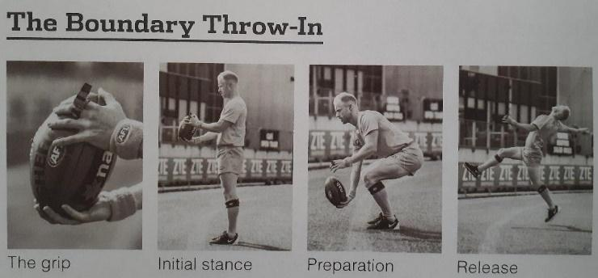

INDICATIONS FOR BOUNDARY UMPIRES
When the ball has passed fully over the boundary line, the umpire blows his whistle loudly and signals to the field umpire with the appropriate signal.
INDICATING OUT OF BOUNDS: When the ball bounces completely over the boundary line, the boundary umpire blows his whistle loudly and extends one arm straight up above his head with his hand open. The boundary umpire looks to the field umpire until the field umpire indicates he can throw the ball in. Once the field umpire signals for the ball to be thrown in, the boundary umpire retrieves the ball and throws it in where it first crossed the boundary line.
INDICATING OUT OF BOUNDS ON THE FULL: When the ball goes completely over the boundary line on the full after being kicked and without having been touched, the boundary umpire indicates out of bounds on the full.
KICK IN BY FULL-BACK: If the full-back, when kicking off after a behind from inside or outside the goal square, kicks the ball over the boundary line without it being touched, the boundary umpire shall give the out of bounds indication. When the ball has passed fully over the boundary line, the umpire blows his whistle loudly and signals the field umpire with the appropriate signal.
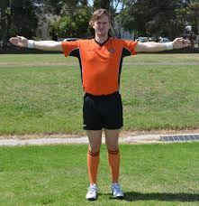
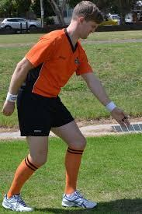
Free kick mark for out on the full Out of bounds on the full 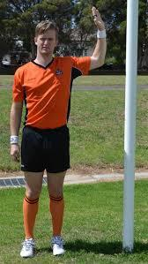
Ball hit post on the full Out of bounds

POSITIONING FOR BOUNDARY UMPIRES
Boundary umpires decide before the match which side of the ground they wish to begin. Sides are then changed each quarter.
DURING GENERAL PLAY: The boundary umpire follows play from goal to goal. He needs to position himself where he can have a good view of the boundary line but ensure he does not interfere with the players contesting the ball. When the play is on the other side of the ground, the boundary umpire moves inside the playing area, but no further than their side of the centre square. Boundary umpires should never place themselves between the players and the ball. When a player is taking a set shot at goal after a mark or free kick, the boundary umpire runs and stands behind the behind post. This allows the boundary umpire to assist the goal umpire. The goal umpire is the sole judge of a score and can overrule the decision of a boundary umpire where necessary.
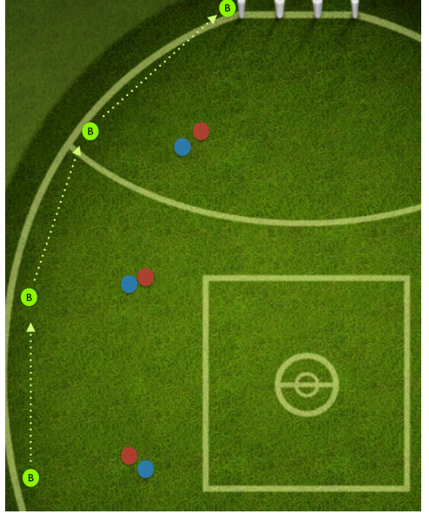

AT THE CENTRE SQUARE: At the beginning of each quarter and after a goal has been scored, the boundary umpires position themselves on diagonally opposite corners of the centre square. They must supervise the square lines that meet at their corners. Once the ball has been bounced or thrown in the air, the boundary umpire moves off towards the boundary line. If the boundary umpire is still running towards the goal when the behind is scored, he shall move quickly to the boundary line and position themselves about 50 metres from the goals.
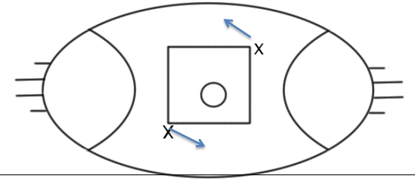

AFTER A BEHIND IS SCORED FROM SET KICK: The boundary umpire is positioned behind the behind post for the set shot. When the goal umpire signals a point, the boundary umpire runs backwards along the boundary line for about 50 metres.

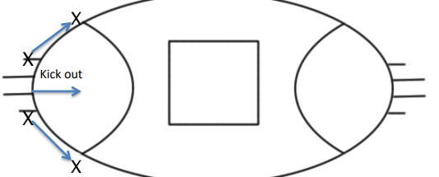

RUNNING THE BALL BACK TO THE CENTRE AFTER A GOAL IS KICKED
After a goal is scored it is the boundary umpire’s responsibility to return the ball to the field umpire. Often the closest umpire to the ball/goals will retrieve the ball. The other umpire will position themselves approximately half-way between the goals and the 50m arc and wait for the ball. The umpire doing the short run will run to meet the umpire doing the long run where they will hand over the ball and continue to the nearest corner. The umpire doing the long run will receive the ball and signal to the field umpire which side they will be running to continue to the furthest corner.
Under no circumstances are any umpires to climb over/under the fence to retrieve the ball! Players/Spectators will retrieve the ball if necessary.
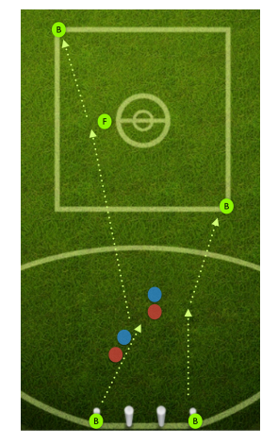

2023 EDFL Training Information
Boundary Umpire (Women’s, U/18, Reserves and Senior Football)
Training at Windy Hill on Tuesday/Thursday, starting at 6.15pm.
From Wednesday 15th February until the end of March, boundary umpires will train Monday & Wednesday each week at Windy Hill.
From Tuesday 4th April and for the remainder of the season training will be every Tuesday & Thursdays commencing at 6pm.
YOUTH UMPIRING TRAINING CENTRES – Junior Umpires
All EDFL Youth Training Centres will commence training on Monday 13th February at the following venues for all Junior Field and Boundary Umpires. Training will then be every Monday night at 5pm (except Public Holidays & School Holidays)

Delahey Umpiring Centre – at Delahey Reserve (Copperfield Drive, Delahey)
Coach Ethan McCall Boundary: Howard Campey

Jacana Umpiring Centre – at Jacana Reserve (corner of Lorraine Crescent & Johnstone Street, Broadmeadows)
Coach Nabil Yassine Boundary

Moreland Umpiring Centre – at Cole Reserve (Cumberland Road, Pascoe Vale)
Coach Lachlan Daly Boundary Angus Drenen

Sunbury Umpiring Centre – at John McMahon Reserve (155 Lancefield Rd, Sunbury)
Coach Daniel Wardley

Craigieburn Umpiring Centre – at Highgate No 2 Oval (Grand Blvd, Craigieburn)
Coach Steve Marrari/Rocky Tranquillo Boundary

Please bring along your water bottle. Training will generally go for 1 hour.
You must bring your whistle and be appropriately attired at every training and coaching session.

EDFL Specific Information 2023
Contact Information
Boundary Coach - Shane Mallia 0410 659 951 (Appointments/Availability)
Administrator - Michael Willcox
Head of Umpiring - Michael Willcox: 0434 689 690 & michael.willcox@essendondfl.com.au
Availability
- Must be sent through no later than 5pm the Friday prior to the round you are unavailable.
- Either by talking to me at training or text message/phone call.
- Must receive an acknowledgement that I have received it.
- Includes all unavailability for a particular time on Saturday e.g. unavailable after 1pm.
- Whether it applies for the season, or just that week.
- Includes public holidays as there are games on GOOD FRIDAY & ANZAC DAY
- Majority of games are on Saturdays, however, some games are on Friday nights and Sundays during Finals.
Confirmation of Appointment
- Must be done no later than Wednesday morning.
- Won’t be spending Wednesday evenings chasing up on people who have not confirmed, I will be replacing them!
- If you need to pull out at late notice (hours before the game) make sure you make contact with one of the above contacts.
- If you are going to be late to the game notify one of the umpires whose numbers can be found on your Schedula appointment.

