Training Session Plan Example

TEAM: EDFL Rep U14 Boys
VENUE: Jacana Reserve
DATE: 2/05/2022
TIME: 6:15pm to 7:15pm
PROGRAM FOCUS AREAS | WAS THIS ACHIEVED?
1. Ground ball gathers
2. Kicks to space
3. Outnumbering at Contest
4. HB in congestion

TIME | ACTIVITY | ACTIVITY DESCRIPTION | TEACHING POINTS/FOCUS | COACH | EQUIPMENT | DURATION
6:00 | Coaches and players arrive | Create a fun environment for players and staff | Engage players. Introduce staff to plyers. All players to introduce themselves to players from other clubs. | Matt | Nil | 7 mins
6:15 | Admin | Explain the training session and goals | Set clear purpose and goals | Matt | Nil | 5 mins
6:20 | Dynamic Warm Up | Dynamic Stretching and Run-Throughs | Use all balls. Players to share the ball while warming up | Jonno | Cones | 8 mins
6:30 | Ground balls | In 3s, rolling ball  - towards the player  - away from player  TM to stay in the ‘V’ & receive HB | “Low and slow beats fast fumbles”  - Slow down  - Fingers under ball  - Bend knees  - Cover ball with your body | Sally | Footballs | 8 mins
6:40 | Grid games - Handball  4 V 2 | Keepings off from opposition  Release player to ‘hit up’ leading forward | Teach players to HB in a triangle in congestion to find a release player  - Outnumbering at contest | Matt/Sally/ Jonno | Footballs Bibs Cones | 7 mins
6:50 | Kicking to advantage | Groups of 3. Work & kick in a triangle. | “Kick to the space, not the face”. | Matt/Sally/ Jonno | Footballs | 7 mins
7:00 | Game simulation | High energy & high speed game  Change lanes, change angles & change direction as much as possible | Coaches DO NOT interrupt game.  - No slow or stop plays in back half  - Give HB to 1st & easiest option - everytime | Matt/Sally/ Jonno | Footballs | 6 mins
7:10 | Warm Down | Slow jog and complete slow and dynamic stretching | Warm down | Sally | Nil | 5 mins
7:15 | Training concluded | Players return to parents
7:20 | Training debrief | Discuss training and outcomes with all coaches | Get players thinking about what they want to achieve | Matt | Nil | 2-5mins

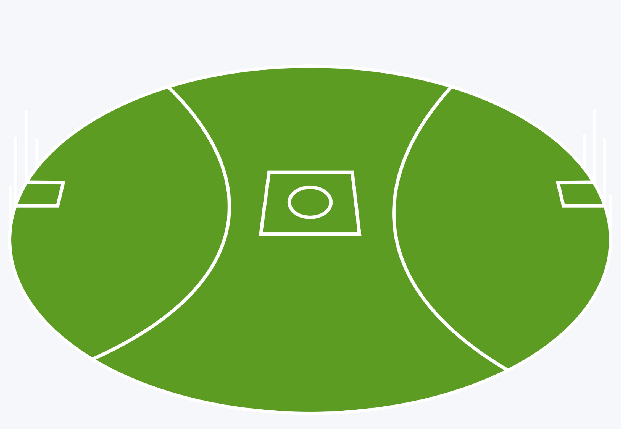
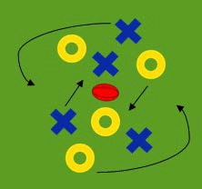
Training Session
Diagram

Craft Work Dynamic Warm Up

Goalkicking Drill

Kicking Out Drill

Game Sense (Square Drills) Midfield Setups

