Training Session Plan Example

TEAM: Smithtown Seniors VENUE: Smithtown Rec Reserve DATE: 03/05/2022
TIME: 5-6:30pm
PROGRAM FOCUS AREAS | WAS THIS ACHIEVED?
1. Kicks to Advantage
2. Clean Hands
3. Outnumbering at Contest
4. Player Communication

TIME | ACTIVITY | ACTIVITY DESCRIPTION | ACTIVITY PURPOSE/FOCUS | COACH | EQUIPMENT | DURATION
5:00 | Training Session Brief | Explain the session and goals | Set Clear Purpose and Goals | Matt | Nil | 5-10mins
5:10 | Dynamic Warm Up | Dynamic Stretching and Run-Throughs | To Warm Up | Sally | Cones | 10-15mins
5:25 | Craft Work (Focus on Kicking) | - Stationary Handballing  - Kick-to-Kick (Both Feet)  - Kick to Leads (in 3’s) | Practice clean hands | Jonno | Footballs | 15mins
5:40 | Game Sense Drills (3v1 Kicking in Square) (4v2 Handballing in Square) | Keepings off from opposition | - Assess decision making off both hand and foot  - Outnumbering at contest | Jonno | Footballs Bibs Cones | 20mins
6:00 | Split into Positions (Position specific drills) | Backs – Kicking out Drill Forwards – Goalkicking Mids – Midfield setups | Work on position specific skills | Matt/Rick/ Jonno | Footballs Bibs Cones Goal Posts | 20mins
6:20 | Warm Down | Players go for a jog and complete static stretching | To Warm Down | Sally | Nil | 5-10mins
6:30 | Training Session Debrief | Discuss training and outcomes | Get players thinking about what they want to achieve | Matt | Nil | 2-5mins

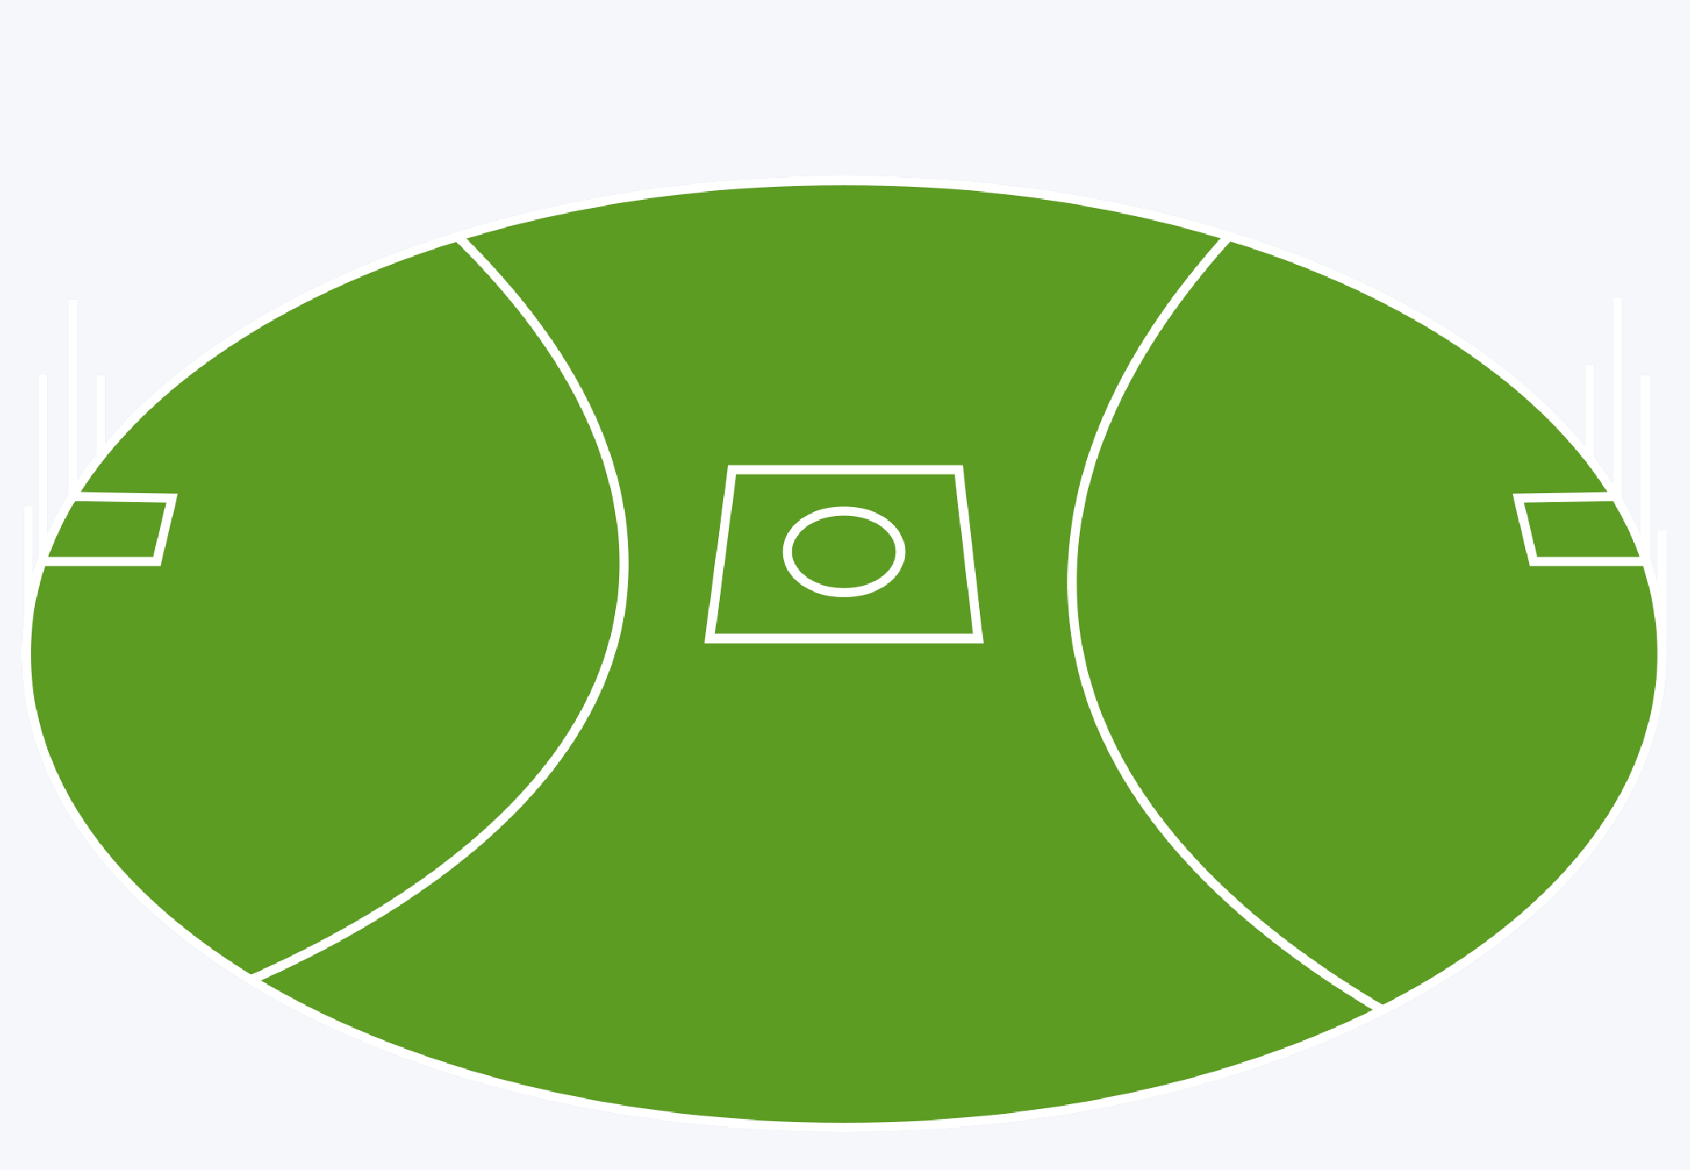
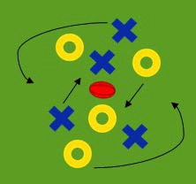
Training Session
Diagram

Craft Work Dynamic Warm Up

Goalkicking Drill

Kicking Out Drill

Game Sense (Square Drills) Midfield Setups

